**Data -**

1. **POPAI | Rate of decision making at Point-of-Sale: 76%** [**https://www.convenience.org/Media/Daily/ND0510124  
   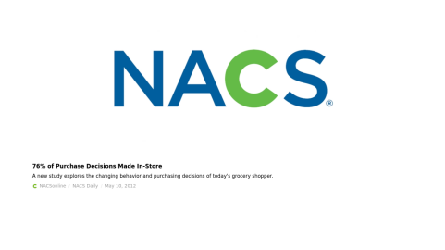**](https://www.convenience.org/Media/Daily/ND0510124)
2. **SHOPPER INTIMACY | Marketing at-Retail generates an average sales lift of 9.2%**

[**https://www.ontraksoftware.com/resource-center/blog/pos-tracking-software/how-to-use-marketing-at-retail-to-increase-sales.html**](https://www.ontraksoftware.com/resource-center/blog/pos-tracking-software/how-to-use-marketing-at-retail-to-increase-sales.html)

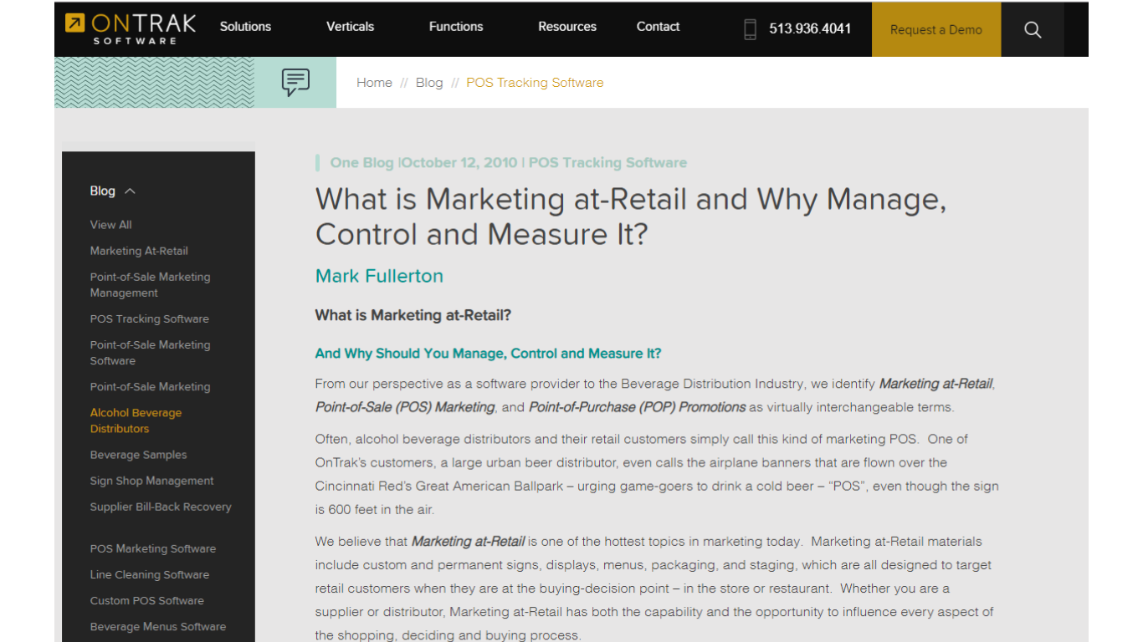

1. **POPAI | Rate of Product purchases increase when POS display is present: 17%**

[**https://memberconnect.shopassociation.org/HigherLogic/System/DownloadDocumentFile.ashx?DocumentFileKey=af210ce1-cdb1-d6fb-7306-8970cb321e60**](https://memberconnect.shopassociation.org/HigherLogic/System/DownloadDocumentFile.ashx?DocumentFileKey=af210ce1-cdb1-d6fb-7306-8970cb321e60)

